TECHNICAL PROJECT REPORT
Glow Beauty: Skincare E-Commerce Portal
Angular 18 Framework | Standalone Architecture

1. Project Aim & Objectives
The Glow Beauty Portal is a modern e-commerce application developed to showcase premium skincare products. The project's primary goal is to demonstrate the integration of Angular's core technical concepts into a professional, aesthetic user interface.

Technical Objectives:
- Implement Directives for dynamic DOM manipulation (Hover Effects).
- Utilize Pipes for data transformation (Currency, Case, and Slugs).
- Manage application state through Reactive Properties in TypeScript.
- Create a modular, scalable structure using Standalone Components.

2. Development Workflow
Phase | CLI Command Used | Description
Init | ng new glow-beauty-app | Project scaffolding & setup.
Component | ng generate component products | Main dashboard development.
Directive | ng generate directive glow | Custom hover interaction logic.
Pipe | ng generate pipe kebab-case | SEO-friendly URL transformation.

3. Code Implementation: Logic Layer

3.1 Component Logic (products.ts)
Handles the product database, reactive filtering, and cart state.
import { Component } from '@angular/core'; import { CommonModule } from '@angular/common'; import { FormsModule } from '@angular/forms'; import { GlowHighlightDirective } from '../glow-highlight'; import { KebabCasePipe } from '../kebab-case-pipe'; @Component({ selector: 'app-products', standalone: true, imports: [CommonModule, FormsModule, GlowHighlightDirective, KebabCasePipe], templateUrl: './products.html', styleUrl: './products.css' }) export class ProductsComponent { storeName = 'Glow Beauty'; selectedCategory = 'All'; cartCount = 0; allProducts = [ { id: 1, name: 'Rose Hydrating Serum', category: 'Serums', price: 48, rating: 4.9, image: '🌹', inStock: true }, { id: 2, name: 'Vitamin C Cream', category: 'Moisturizers', price: 52, rating: 4.8, image: '🍊', inStock: true }, { id: 3, name: 'Gentle Cleanser', category: 'Cleansers', price: 28, rating: 4.7, image: '🫧', inStock: true }, { id: 4, name: 'Retinol Night Mask', category: 'Masks', price: 65, rating: 4.9, image: '🌙', inStock: false } ]; get filteredProducts() { if (this.selectedCategory === 'All') return this.allProducts; return this.allProducts.filter(p => p.category === this.selectedCategory); } addToCart(name: string) { this.cartCount++; alert(`Added ${name} to cart!`); } filterByCategory(cat: string) { this.selectedCategory = cat; } }

3.2 Custom Glow Directive (glow-highlight.ts)
@Directive({ selector: '[appGlow]', standalone: true }) export class GlowHighlightDirective { constructor(private el: ElementRef) {} @HostListener('mouseenter') onMouseEnter() { this.el.nativeElement.style.backgroundColor = '#fdf2f8'; this.el.nativeElement.style.boxShadow = '0 10px 25px rgba(219, 39, 119, 0.2)'; } @HostListener('mouseleave') onMouseLeave() { this.el.nativeElement.style.backgroundColor = ''; this.el.nativeElement.style.boxShadow = ''; } }

3.3 Template View (products.html)
<div class="shop-wrapper"> <header class="navbar"> <h1>{{ storeName | uppercase }}</h1> <div class="cart">🛒 {{ cartCount }}</div> </header> <section class="filters"> <button *ngFor="let cat of categories" (click)="filterByCategory(cat)"> {{ cat }} </button> </section> <div class="product-grid"> <div class="card" *ngFor="let p of filteredProducts" appGlow> <div class="img">{{ p.image }}</div> <h3>{{ p.name }}</h3> <p>/products/{{ p.name | kebabCase }}</p> <button (click)="addToCart(p.name)">Buy {{ p.price | currency }}</button> </div> </div> </div>

3.4 Custom Kebab-Case Pipe (kebab-case-pipe.ts)
@Pipe({ name: 'kebabCase', standalone: true }) export class KebabCasePipe implements PipeTransform { transform(value: string): string { if (!value) return value; return value.replace(/\s+/g, '-').toLowerCase(); } }

4. Visual Project Output
The following sections provide evidence of the successful execution and rendering of the application features.

4.1 Final Landing Page View
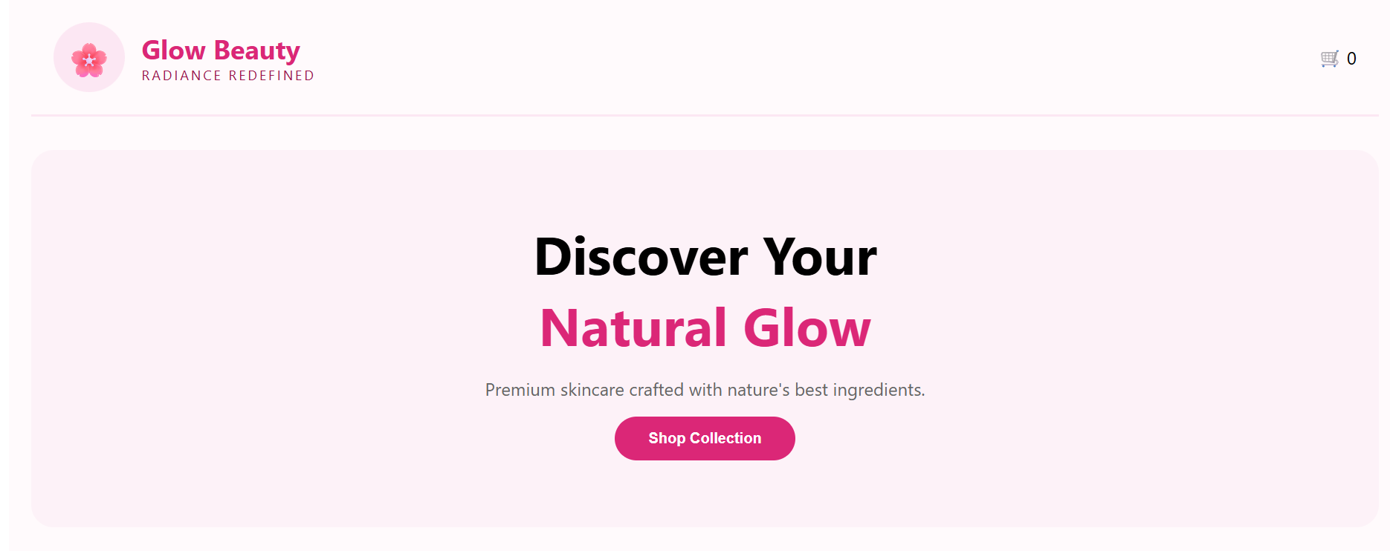

4.2 dashboard
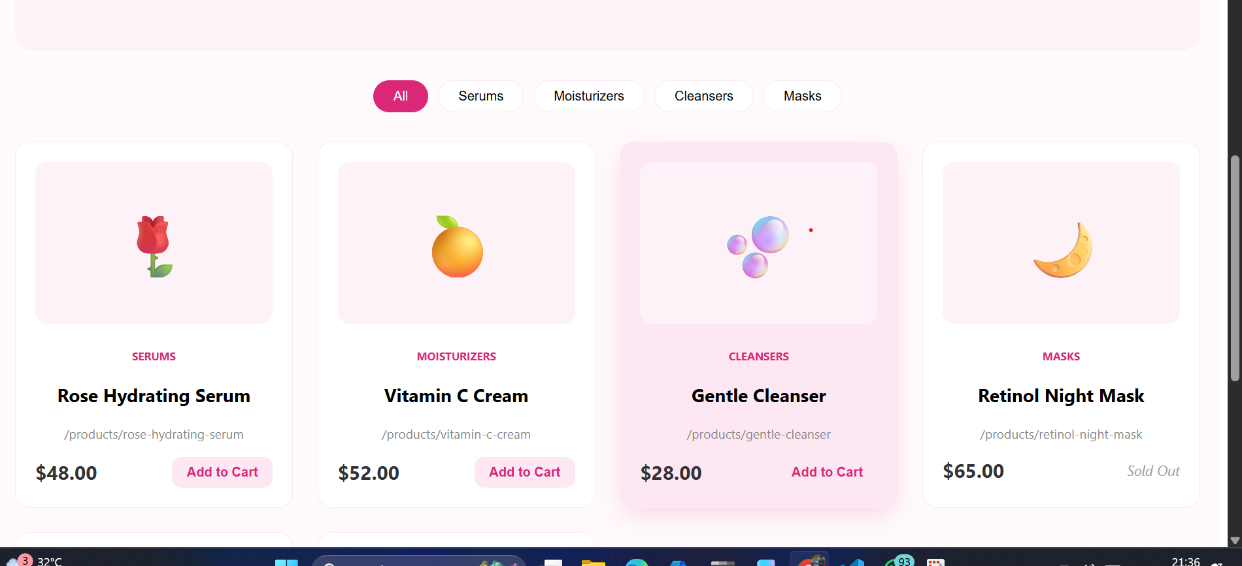

4.3 Interactive Hover Glow (Directive Demo)
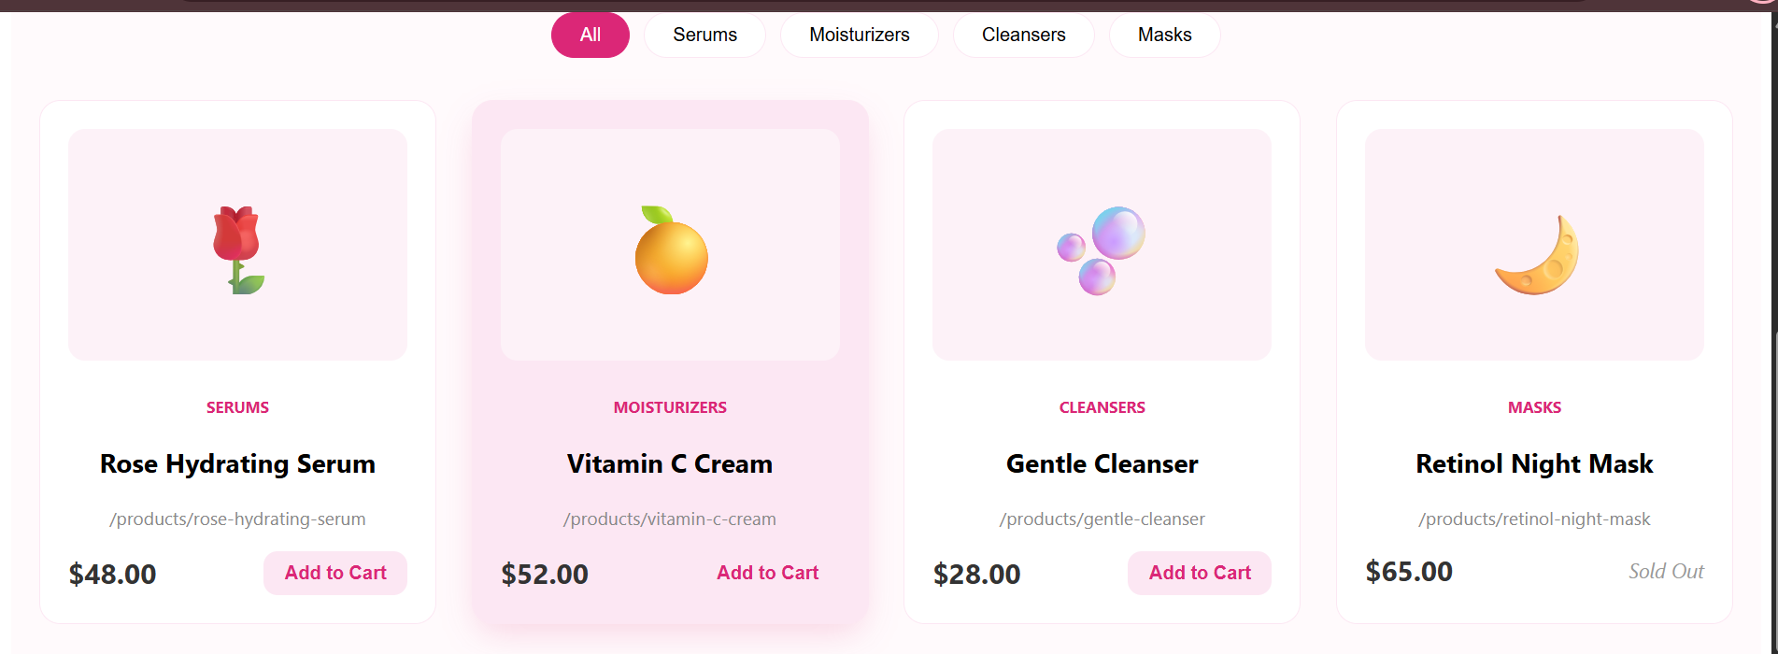

4.4 Shopping Cart & Pipe Validation
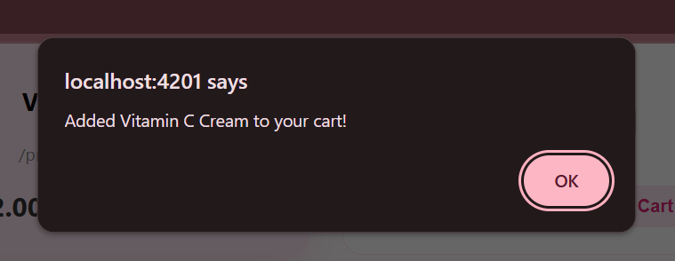

5. Conclusion
The project was completed successfully, achieving all technical objectives. The application demonstrated the versatility of Angular in building high-end, data-driven interfaces. By utilizing custom directives and pipes, the "Glow Beauty" portal provides a unique and professional user experience.

